|  |  |  |
| --- | --- | --- |
|  |  |  |
|  |  |

|  |  |
| --- | --- |
| **MINISTRY OF EDUCATION**  **IMAM ABDULRAHMAN BIN**  **FAISAL UNIVERSITY**  **COLLEGE OF COMPUTER SCIENCE**  **& INFORMATION TECHNOLOGY** | **وزارة التعليم**  **جامعة الإمام**  **عبدالرحمن بن فيصل**  **كلية علوم الحاسب**  **وتقنية المعلومات** |



Phase 2

**Project Group Number in Blackboard** (3):



**Program Name: √**CS

**Section Number**: √ Group (1)

**Project Title:** *Baking Bites E-blog*

|  |  |  |  |
| --- | --- | --- | --- |
| Leader | ID | Member Name | Email Address |
| √ | 2170000146 | Zahra Alhadab | 2170000146@iau.edu.sa |
|  | 2170002126 | Nadiea Alfardan | 2170002126@iau.edu.sa |
|  | 2170004511 | Arwa Alyahya | 2170004511@iau.edu.sa |
|  | 2160006120 | Dana Boujlea | 2160006120@iau.edu.sa |
|  | 2170003349 | Maha Balharith | 2170003349@iau.edu.sa |
|  | 2170005567 | Hissa Abahussain | 2170005567@iau.edu.sa |
|  | 2170005252 | Shaikah Alfares | 2170005252@iau.edu.sa |
|  | 2180006622 | Jumana Alghamdi | 2180006622@iau.edu.sa |
|  | 2170008191 | Maryam Alayaat | 2170008191@iau.edu.sa |

1. Website

1.1 Newsletter pop-up

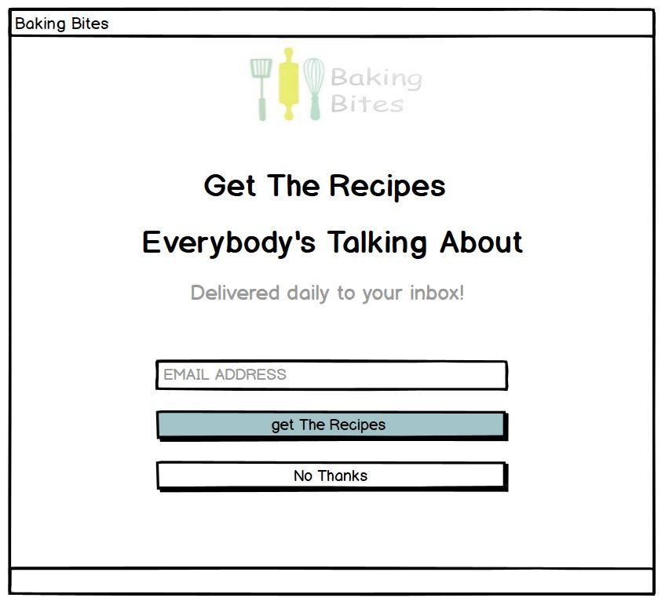

This window pops up the first thing when the user visits the website.

1.1.1 Home

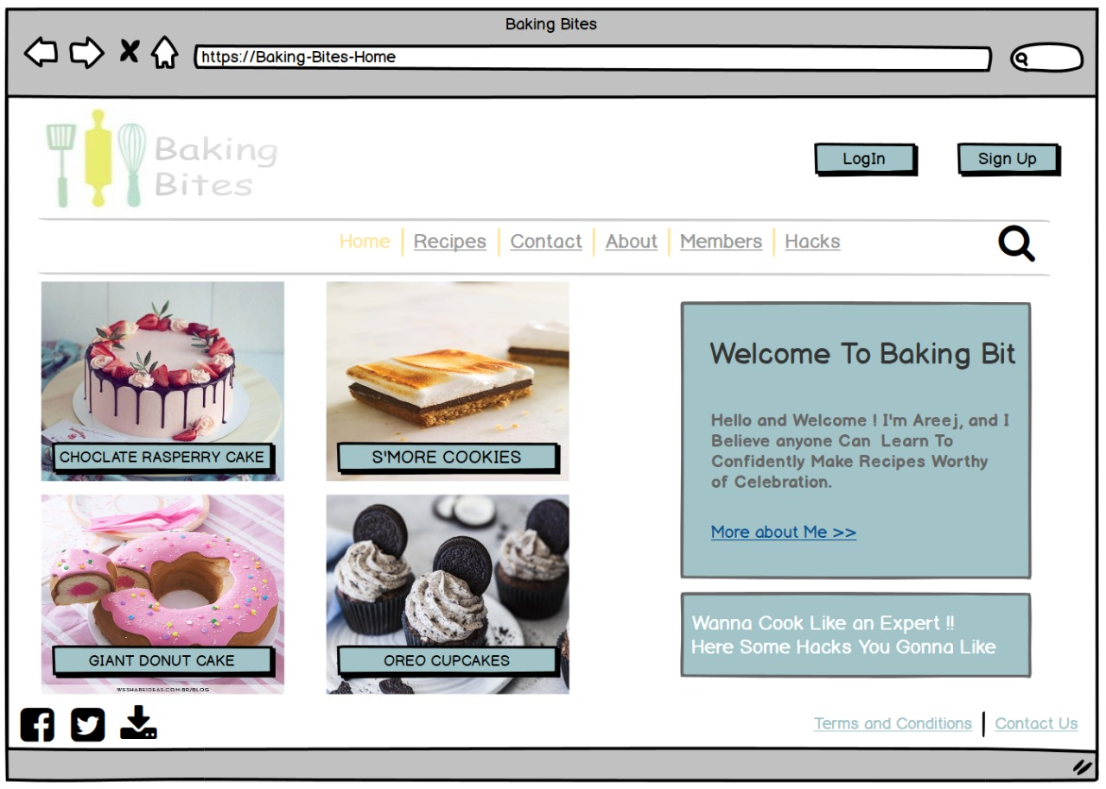

This page shows experts hacks by pressing on the box message from the home page.

* + 1. Hacks and Tips page

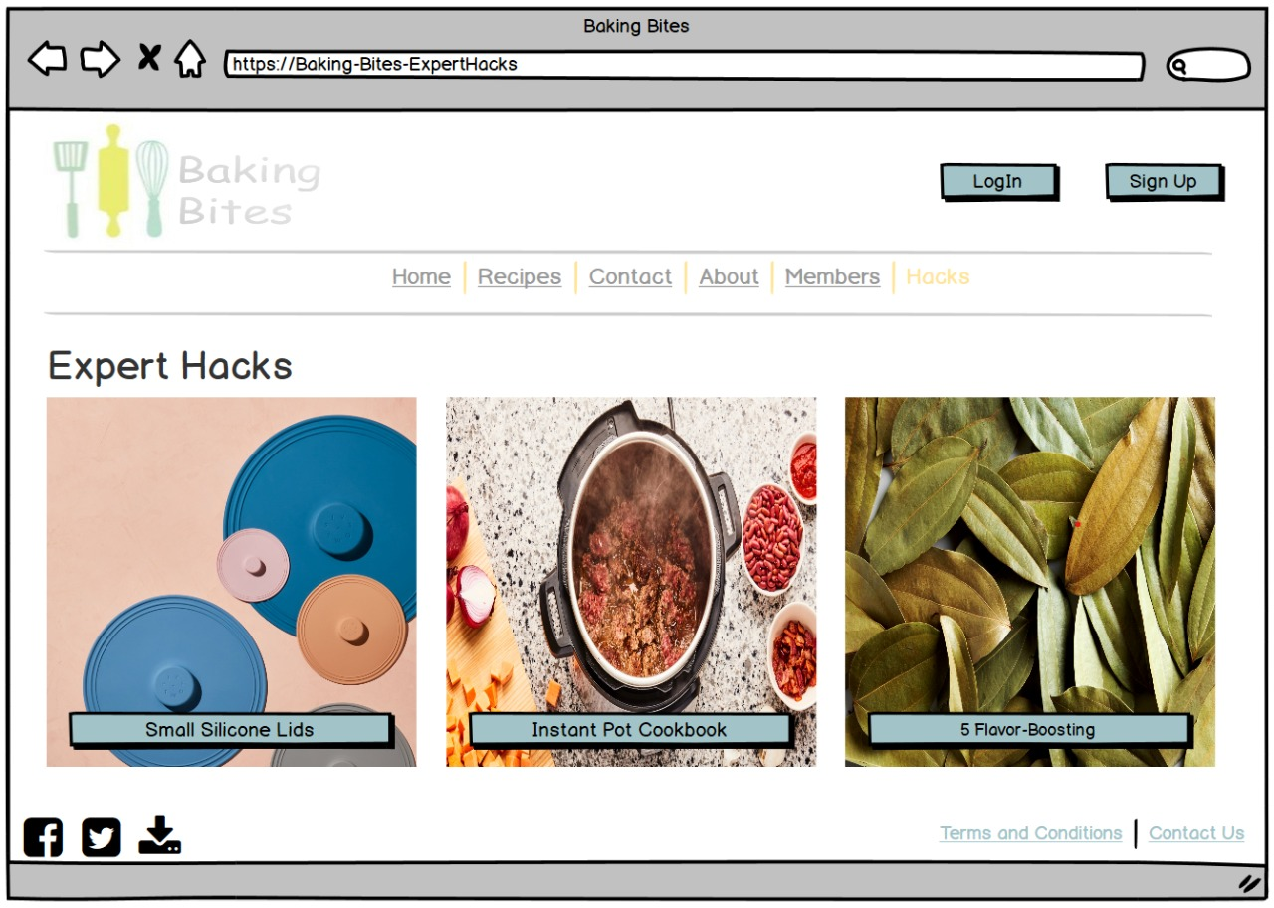

* + - 1. An article in the hack section

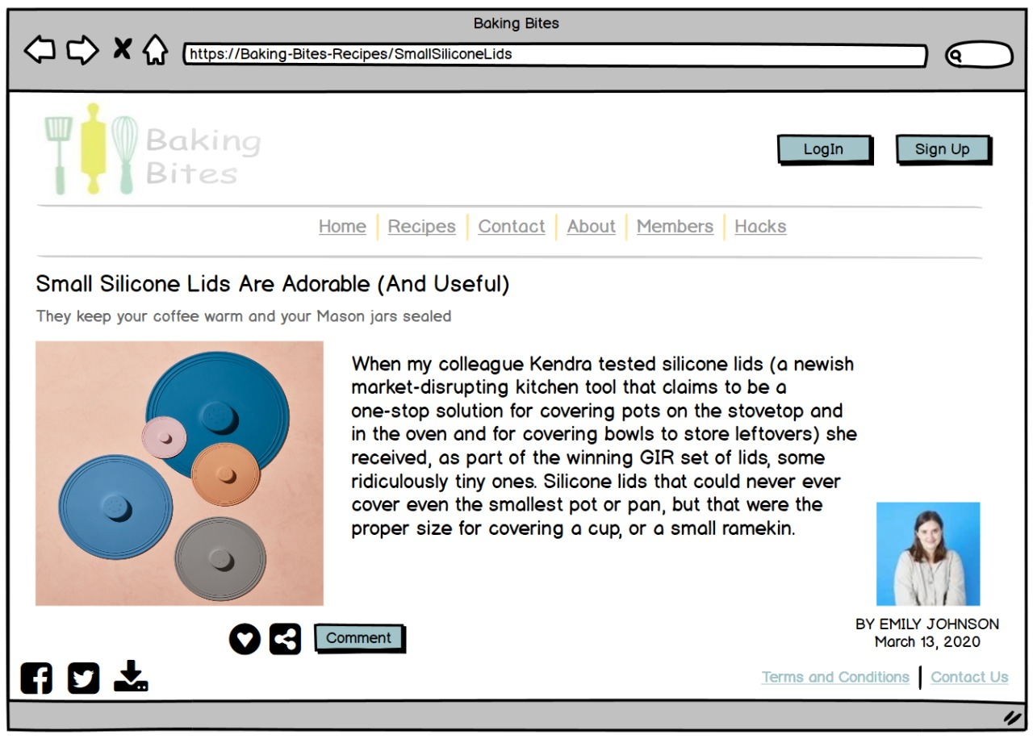

First article of this section.

You can visit author’s profile by clicking on her Photo

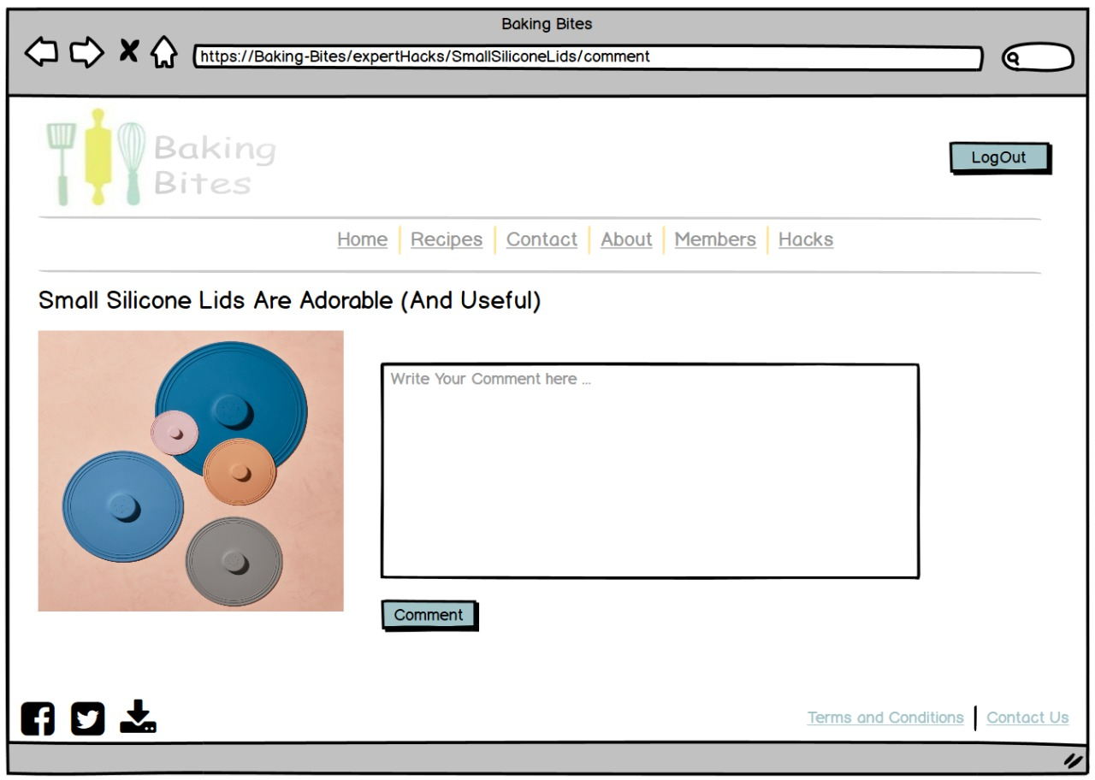

The comment button will show this page that let the user leave a comment in the article (if you were a member).

1.2 Recipes





Only Members Can Like, Comment, and share the posts of the recipes.

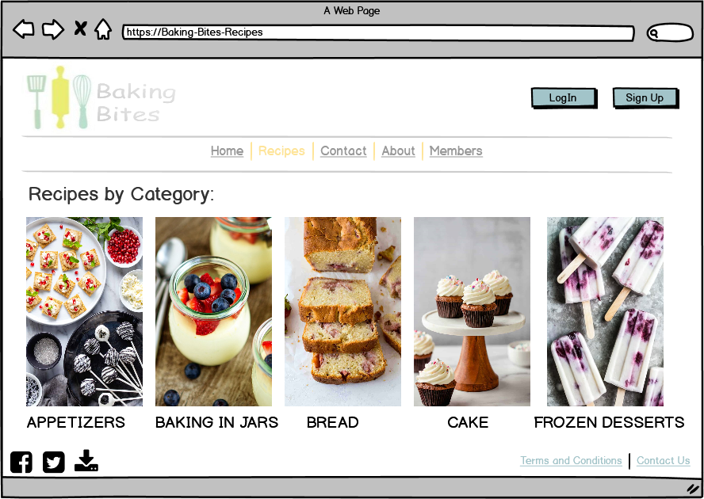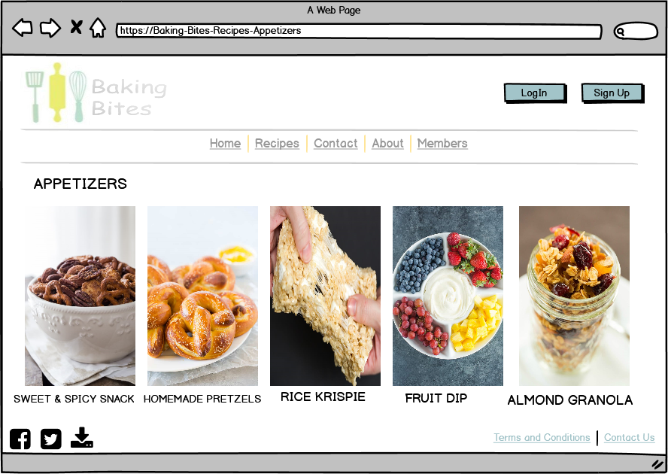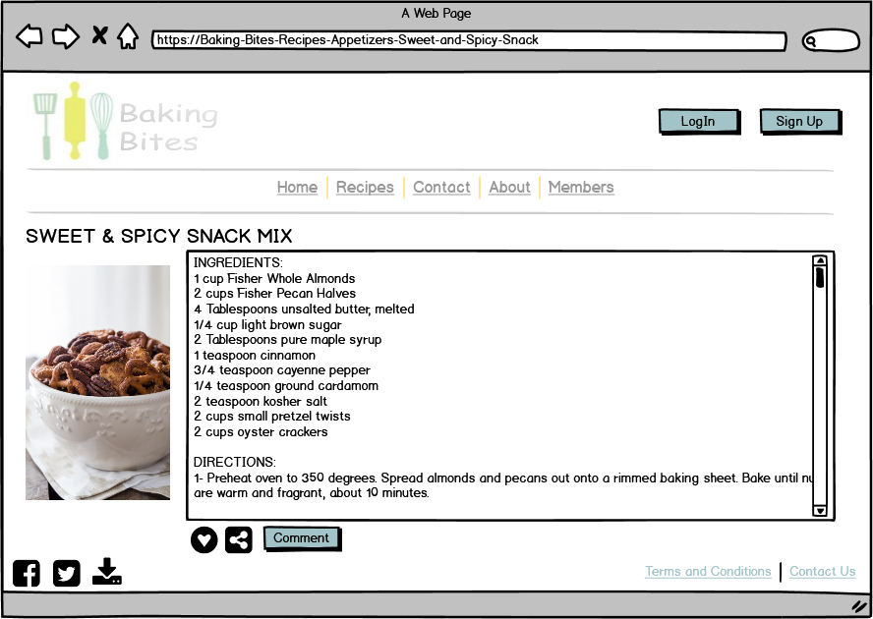

1.2.1 Comment

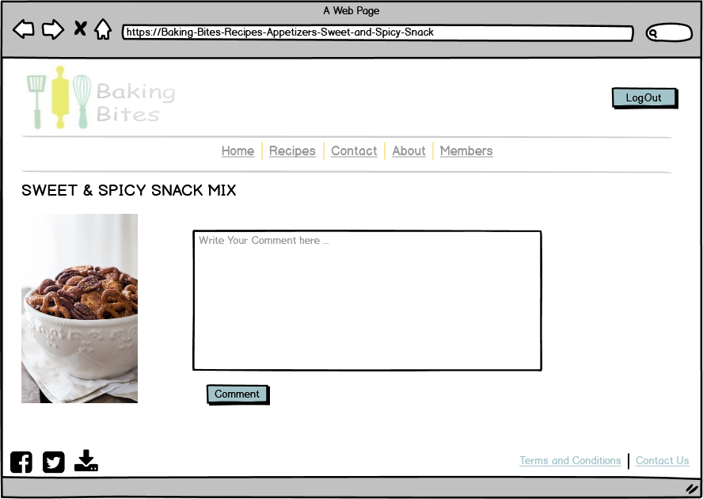

If a Member (Subscriber/Author) Click on Comment button this Interface will appear.

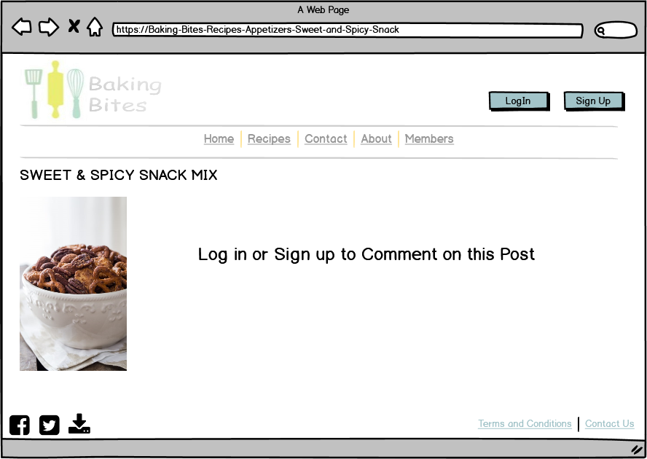

If a Visitor Click on Comment button this Interface will appear.

1.3 Contact Us

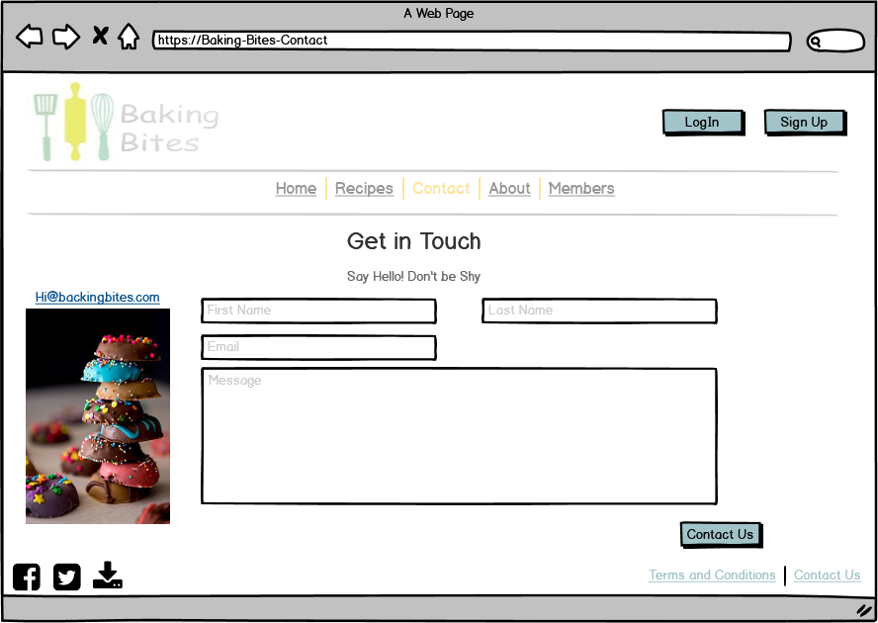

The Visitors Can contact for any issue or questions.

1.4 About

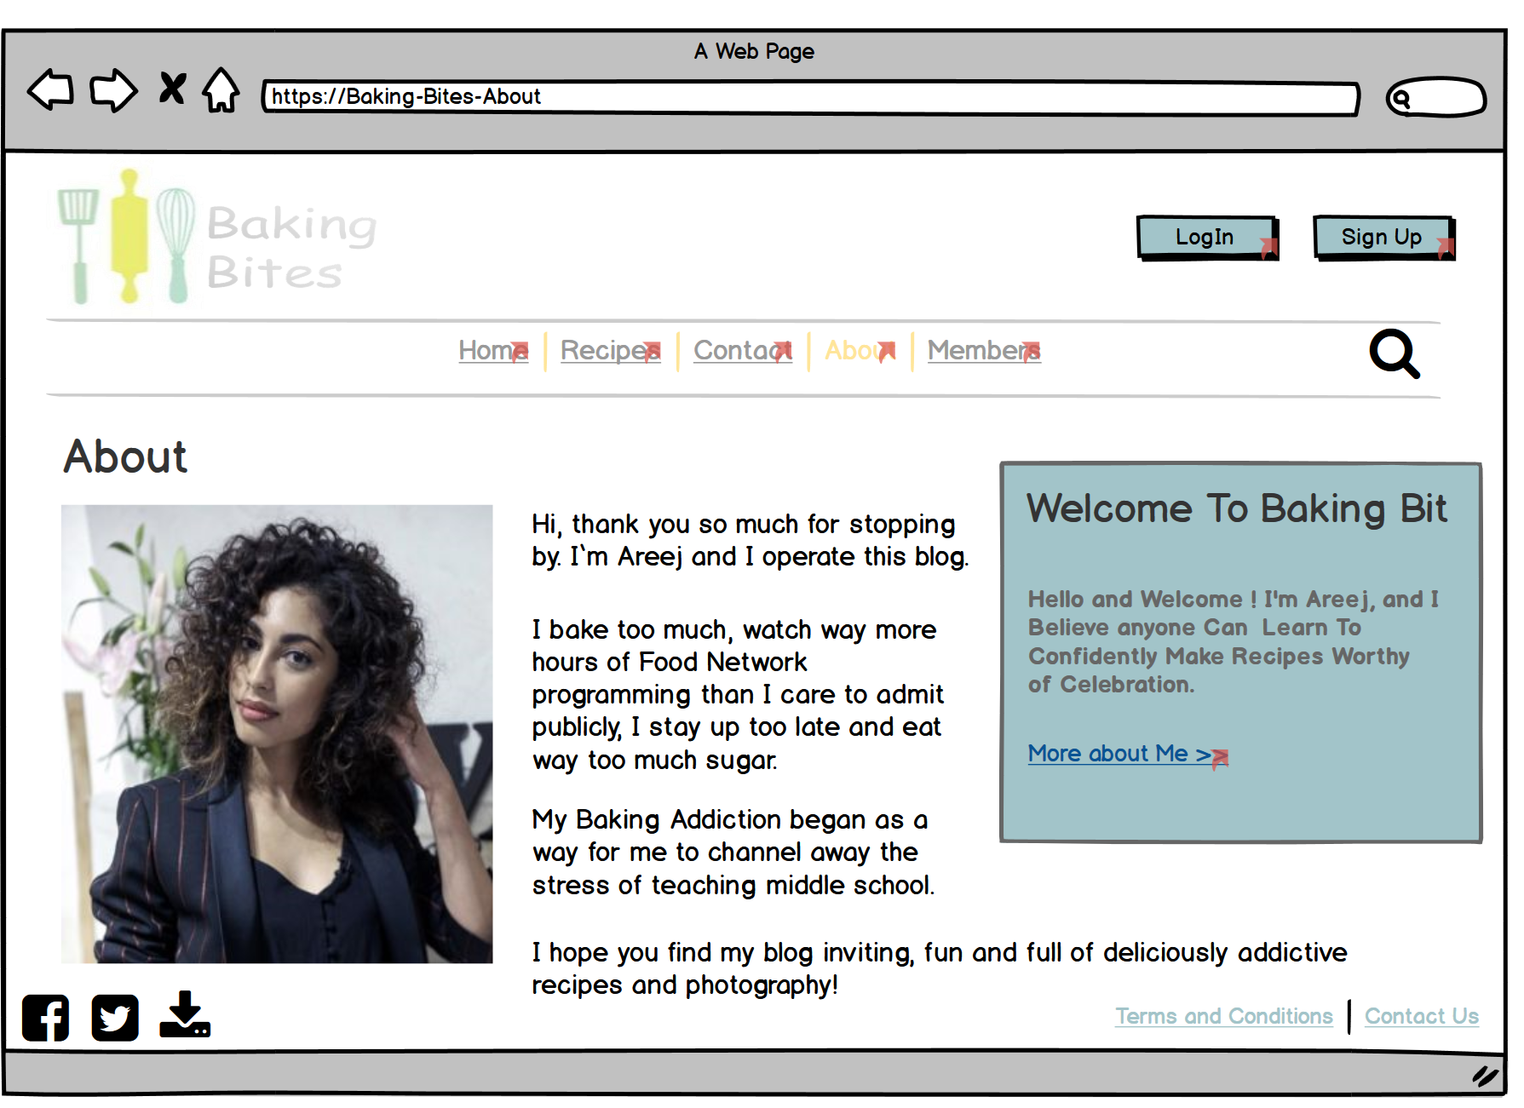

1.5 Members

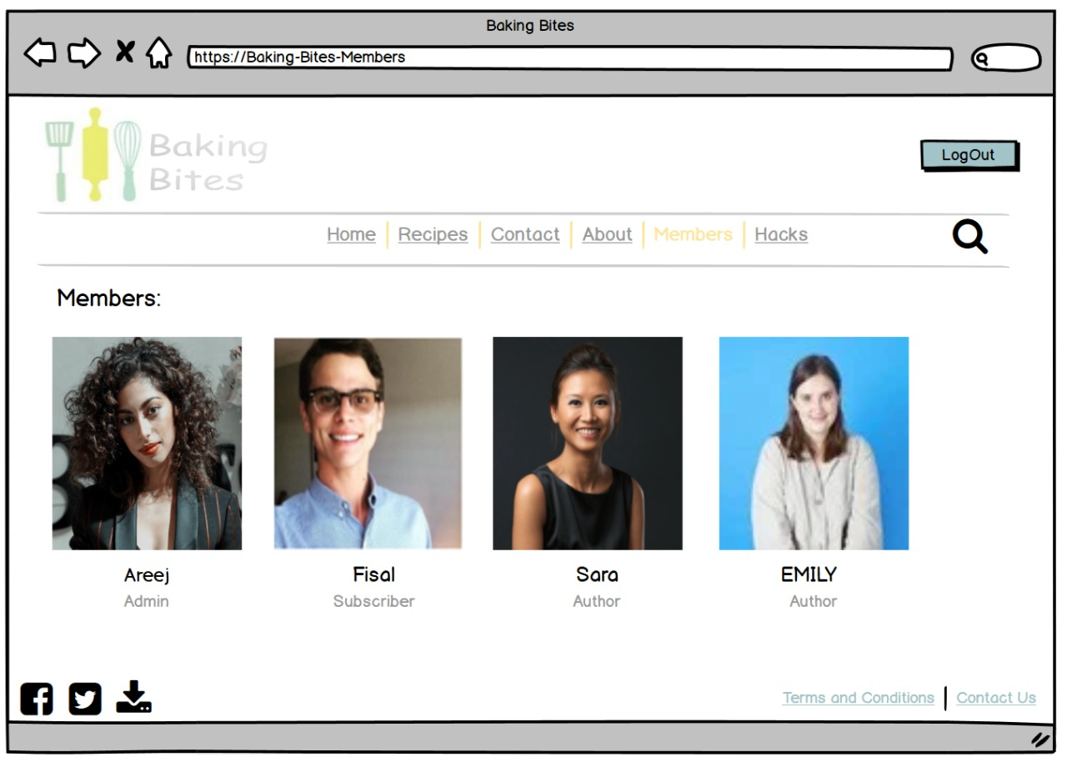

If a Member (Subscriber/Author) clicks on the Members Page this Interface will appear.

1.5.1 Member (Subscriber/Author)

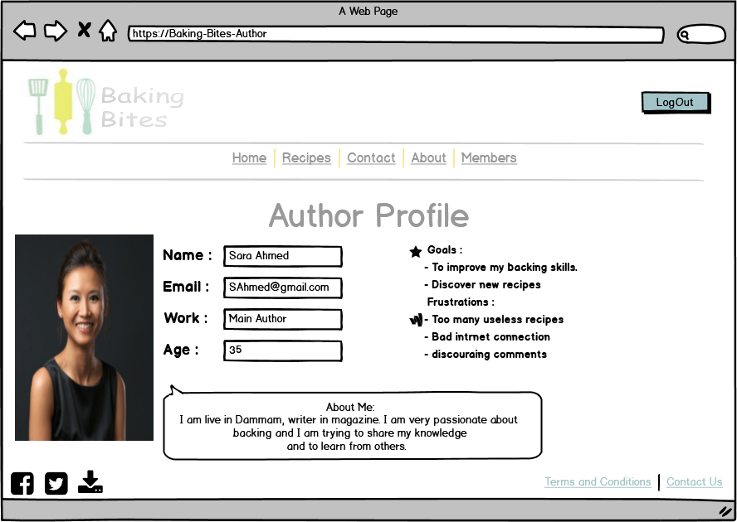

If a Member (Subscriber/Author) Click on any Member Name, it will open his profile page.

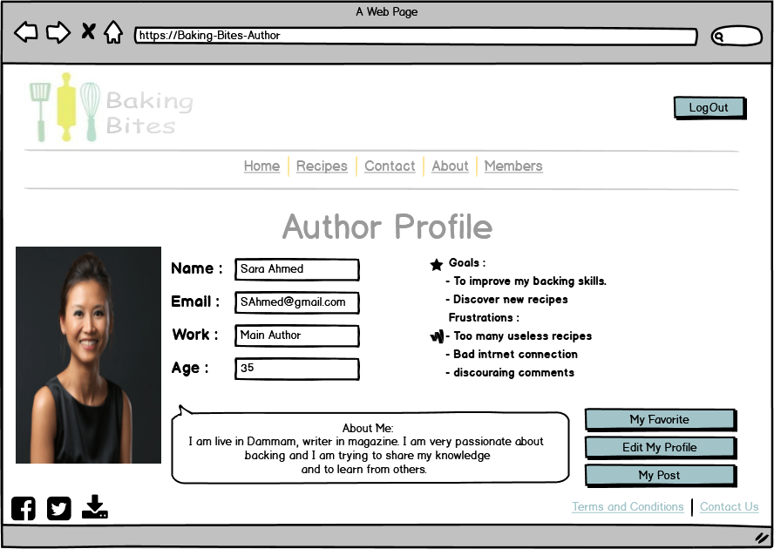

My Post button: Where the Author can find his/her published posts.

Edit My Profile button: To Edit the profile info.

My Favourite button: Where the Member can find the posts, he/she added it to his/her Favourite.

If I Logged in as Member and Click on My Name in Members page This interface will appear.

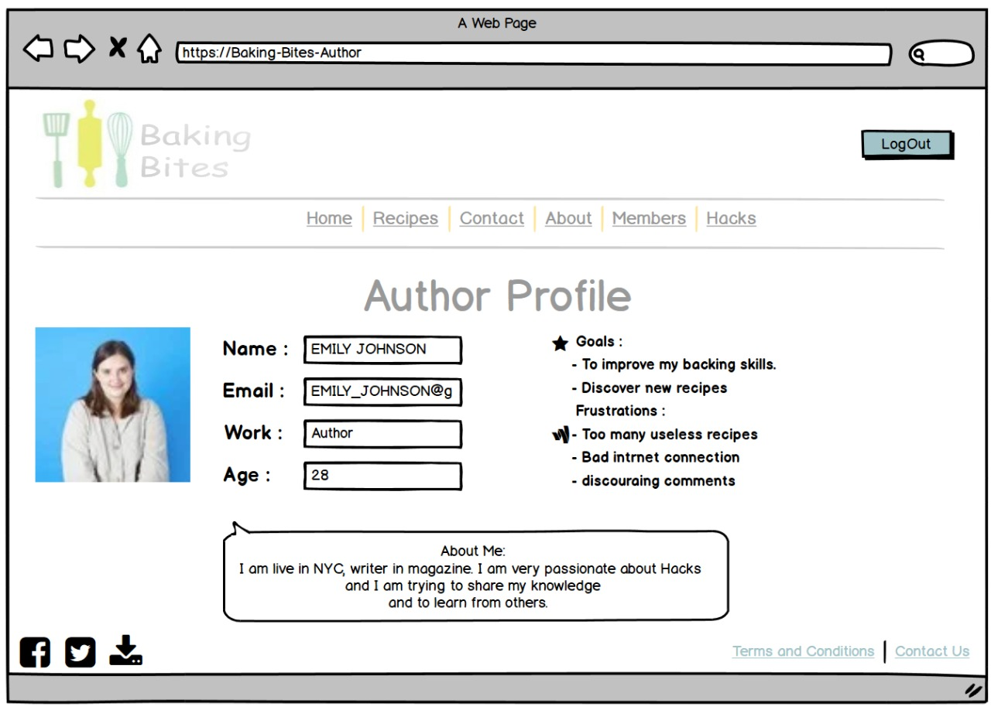

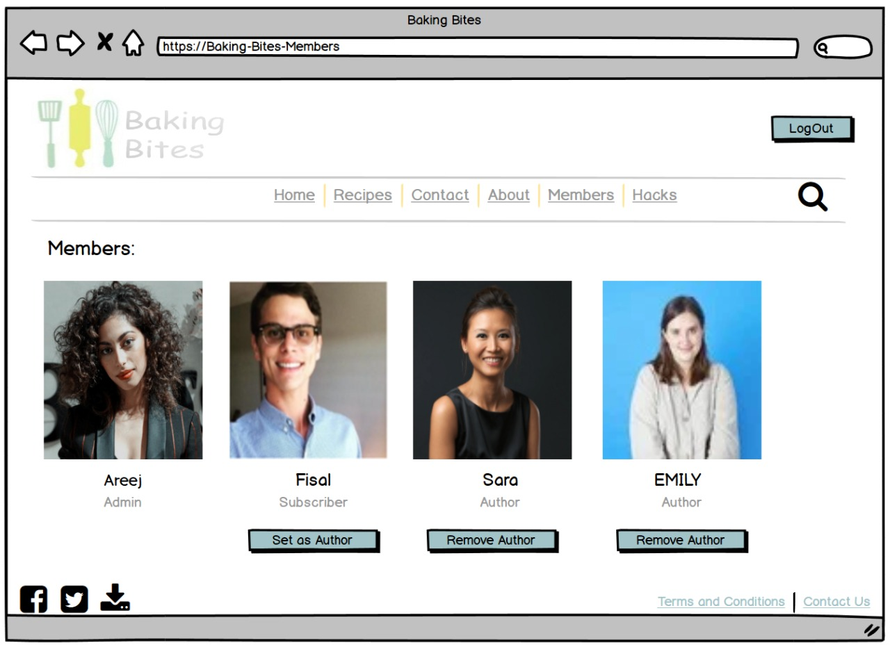1.5.2 Admin

Only the Admin have the authority To Set other Members as Authors.

If the Admin Click on Members Page this Interface will appear.

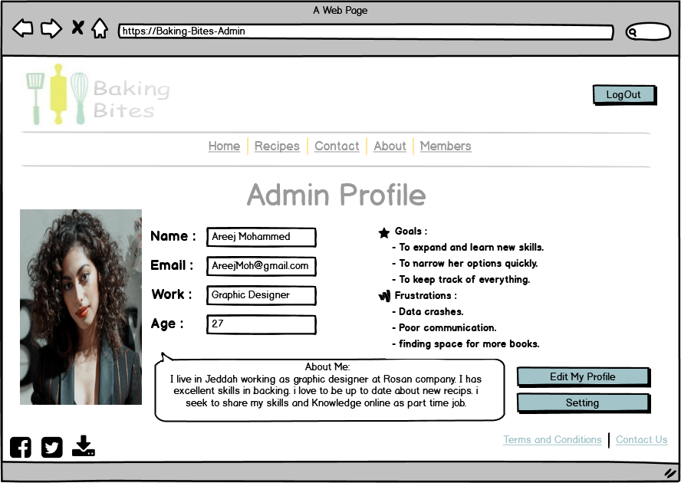

Setting button: This button will take the admin to her Setting

Edit My Profile button: To Edit the profile info.

If I Logged in as Admin and Click on My Name in Members page This interface will appear.

1.5.2.1 Admin Settings

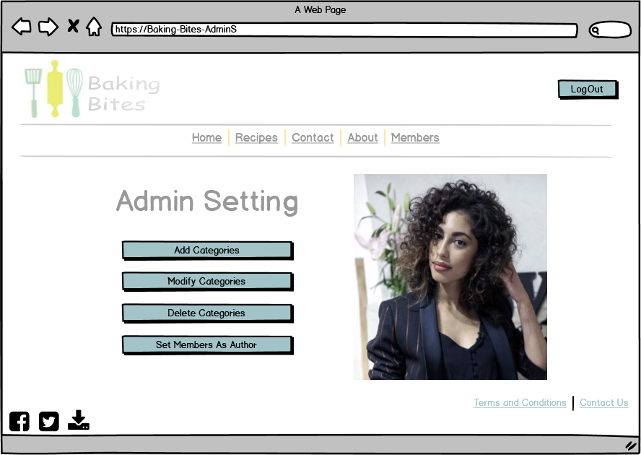

Only the Admin have the authority To Set other Members as Authors.

Only the Admin have the Authority to Add, Modify, and Delete The recipes Categories.

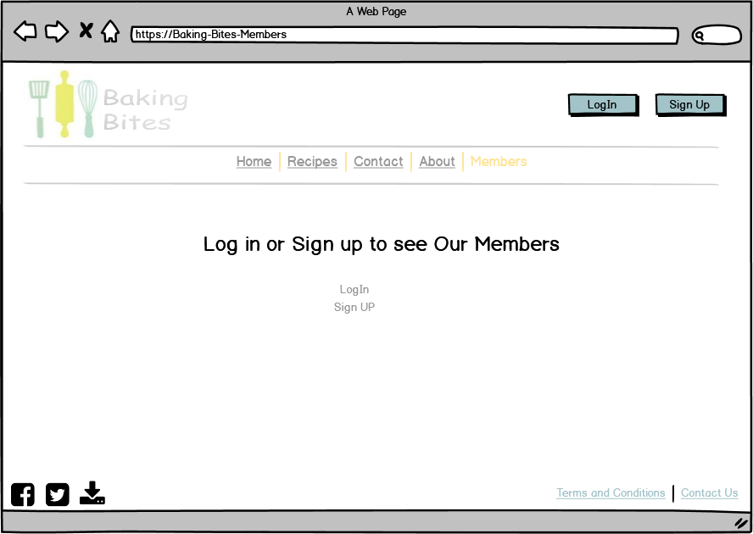

1.5.3 Visitor

If a Visitor Click on Members Page this interface will appear.

1.6 Sign Up

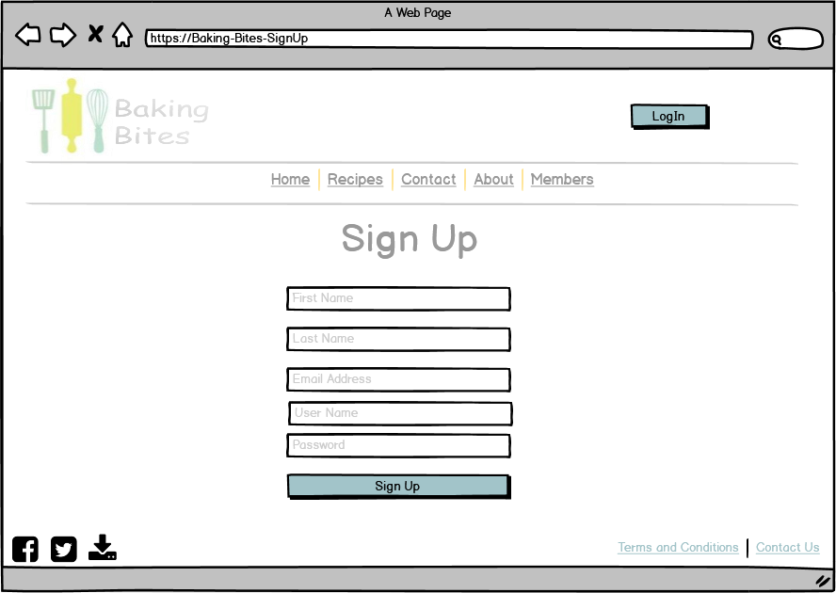

1.7 Log In

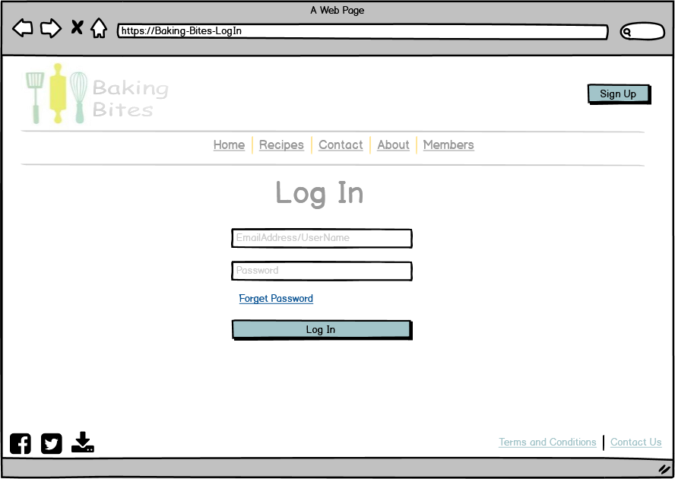

1.8 Post a Recipe

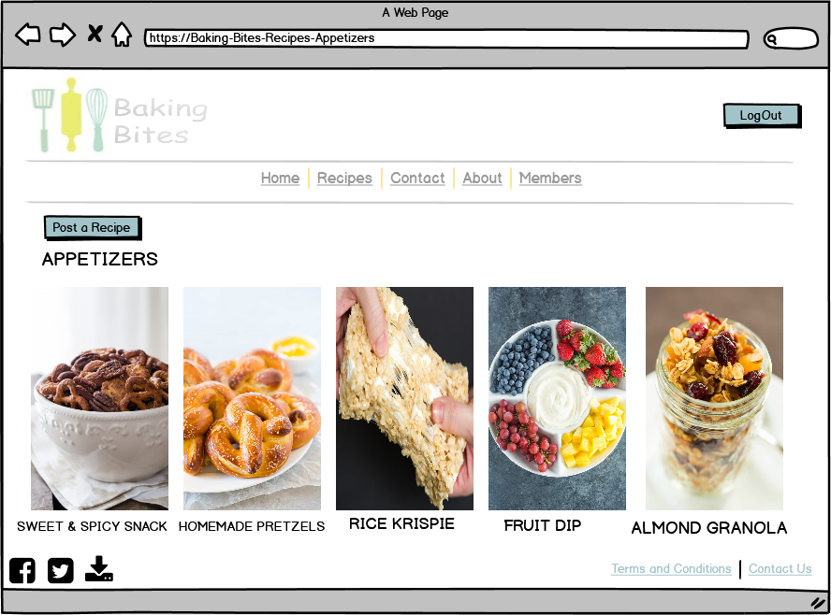

Only Admin and Author Can post a recipe.

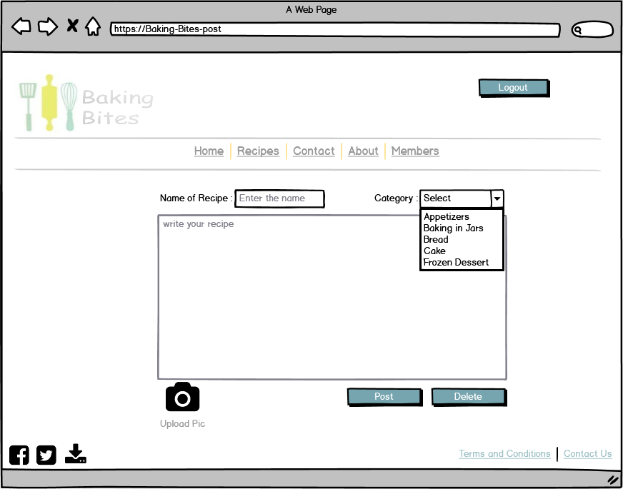

1.9 Search a recipe

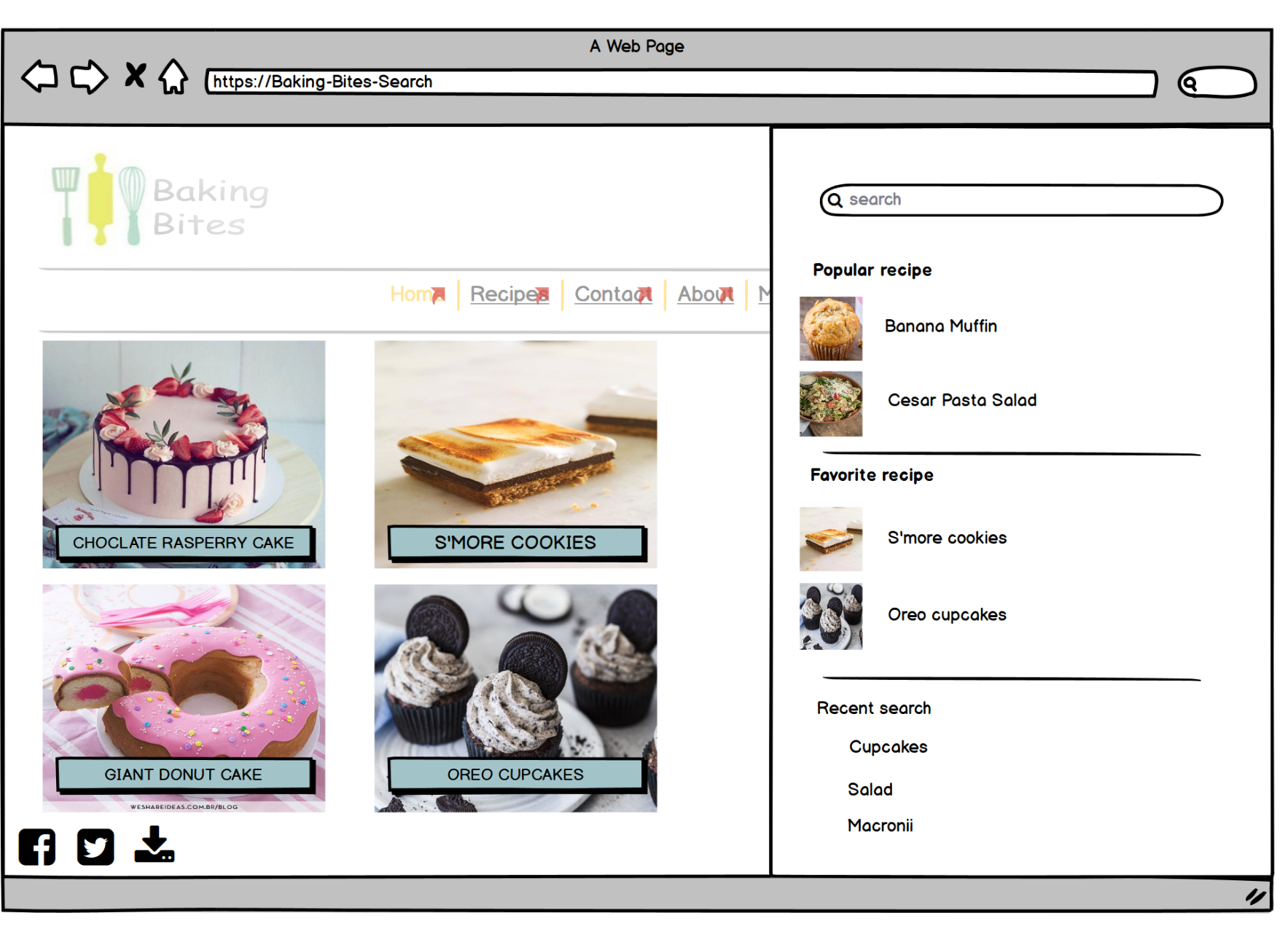

Search button shows a side menu with the search bar. It also includes some history search, favorite recipes, and some popular searches.

**2 Mobile Application**

**2.1 Home Page:**

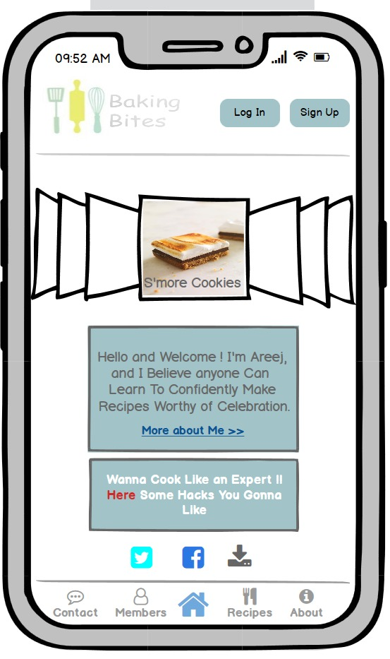

**2.2 Hacks page**

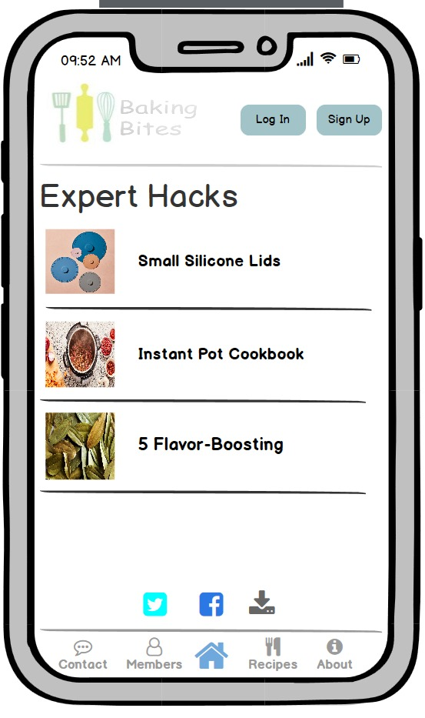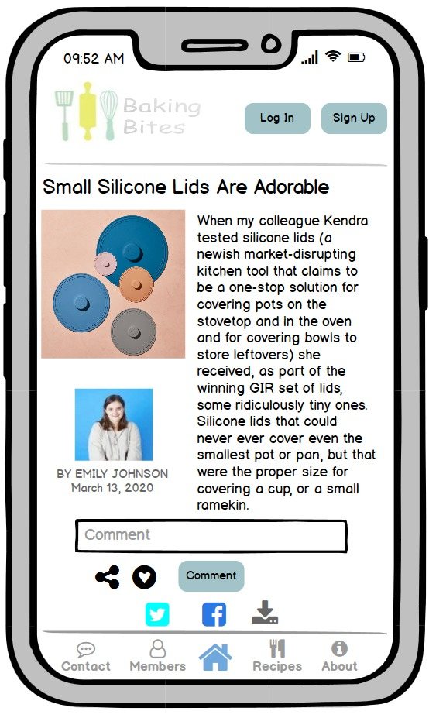

**2.3 About Page:**

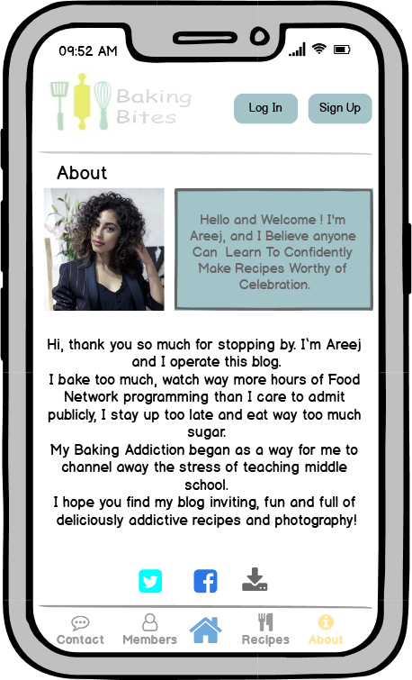

Users can go to the **About Page** from the menu bar at the bottom of the screen

**2.4 Contact Page:**

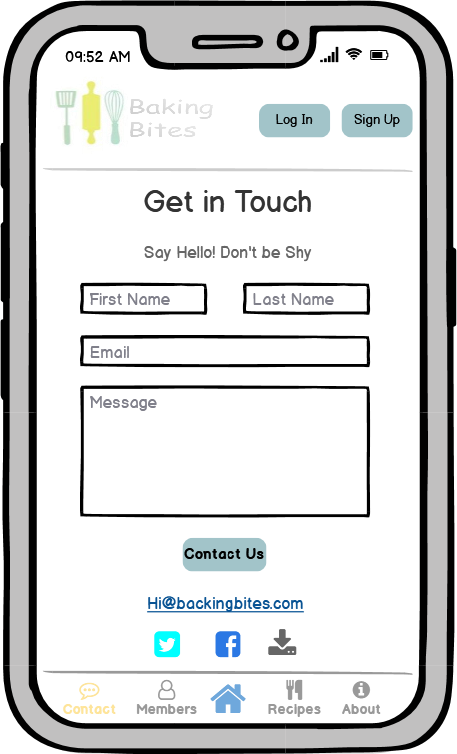

Users can go to the **Contact Page** from the menu bar at the bottom of the screen

**2.5 Recipes Pages:**

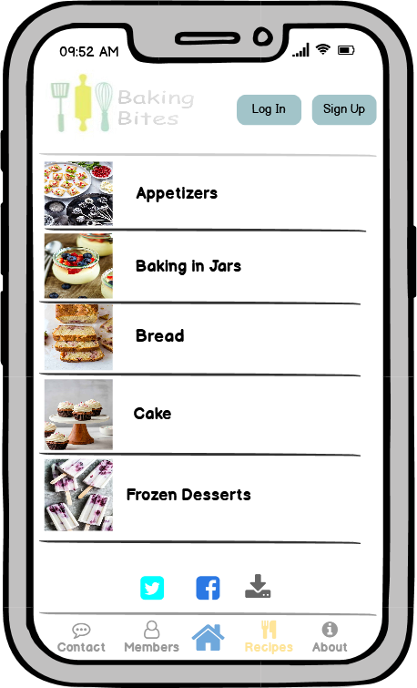 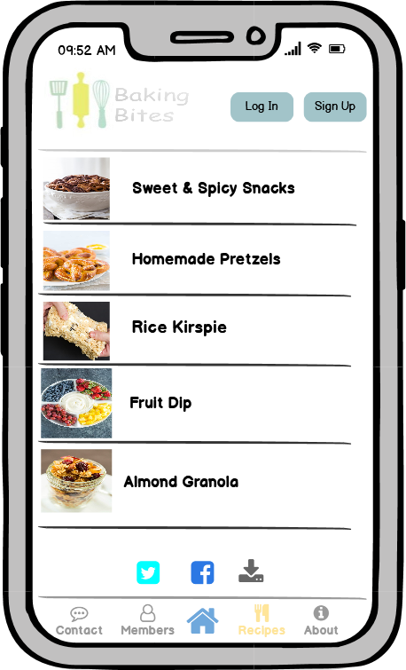 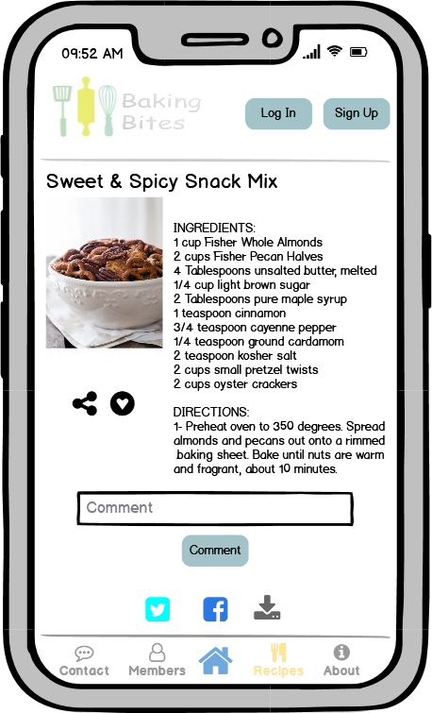

Users can go to the **Recipes Page** from the menu bar at the bottom of the screen

**2.6 Search Recipes Page**

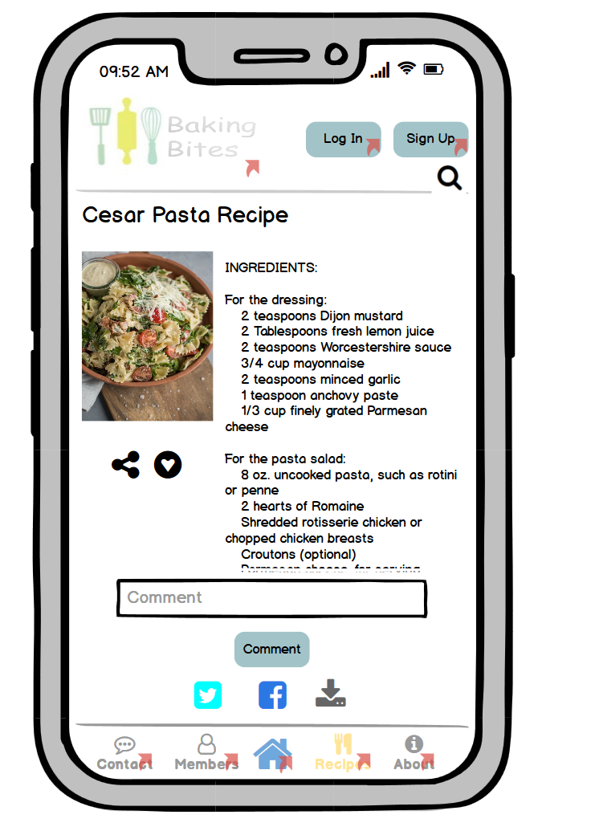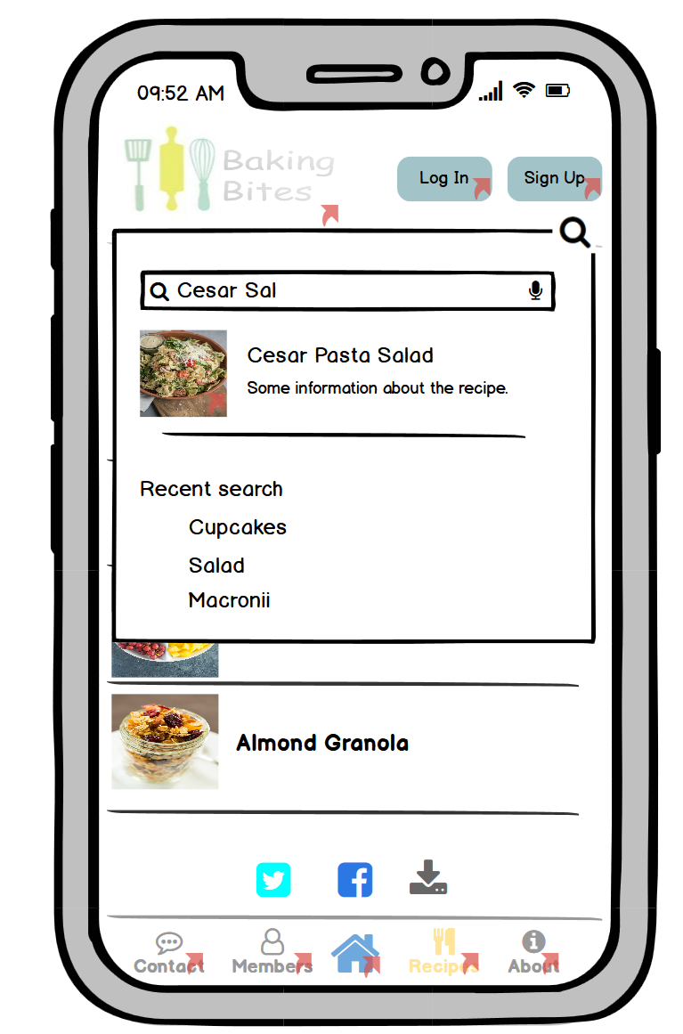

**2.7 Comment Pages:**

 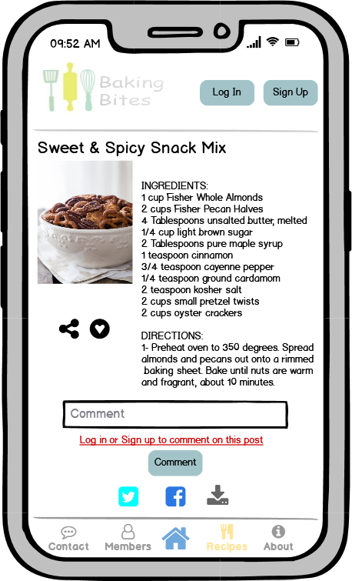

If the user wants to comment on a recipe, they must be signed in. if they’re not signed in a message appears to tell them to sign in.

**2.8 Members Page:**

**2.8.1 Not Signed In/Up**

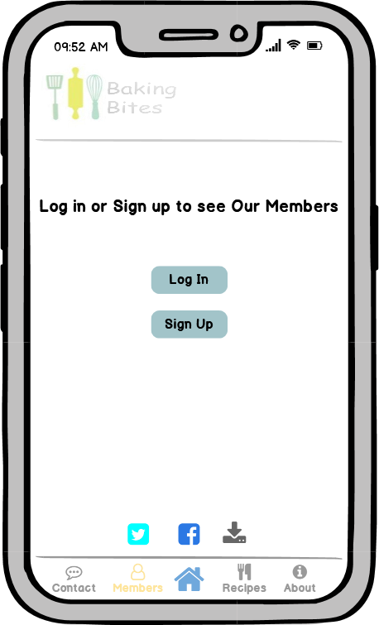

Users can go to the **Members Page** from the menu bar at the bottom of the screen

If they’re not signed in, then this interface appears to tell them to sign in/up

**2.8.2 Sign In/Up Pages**

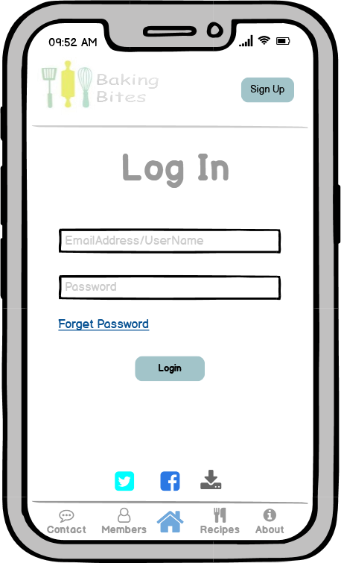 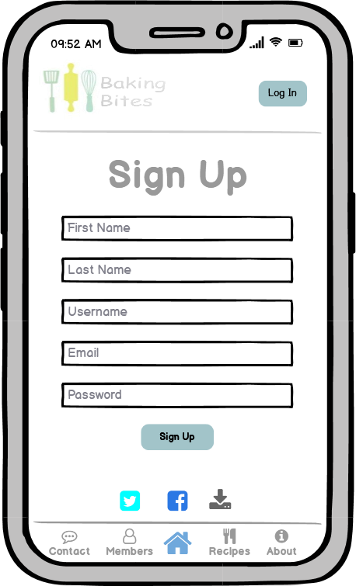

**2.8.2.1 Signed in as Admin**

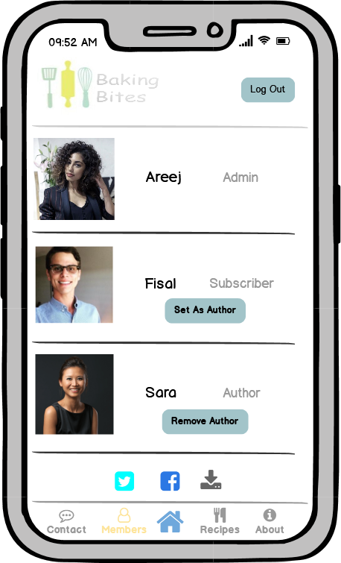 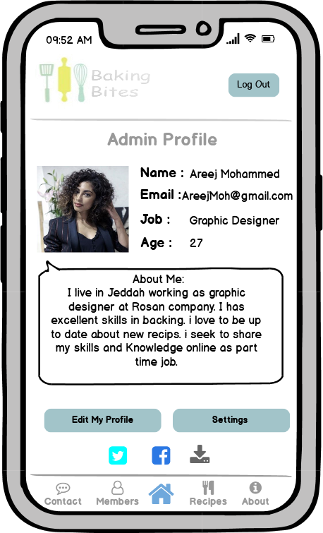 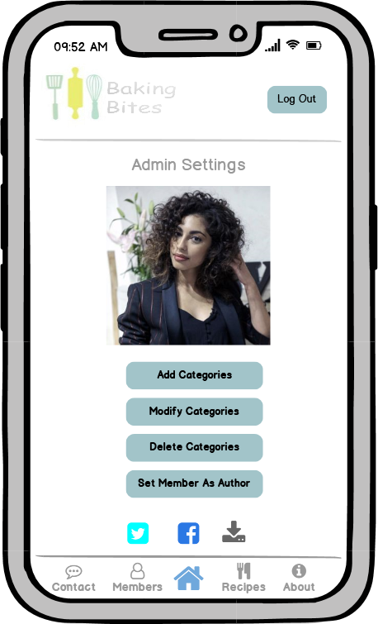

The **Members Page** appears like this if the user is an ***Admin***, they can set or remove members as authors.

The **Admin** can modify the categories, unlike other members.

**2.8.2.2 Signed In as subscriber/Author**

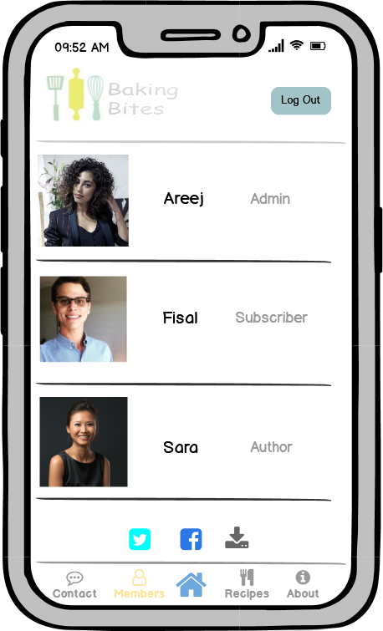 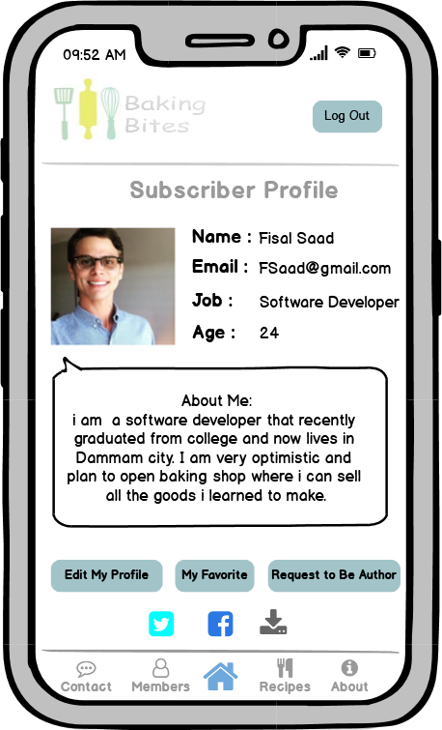 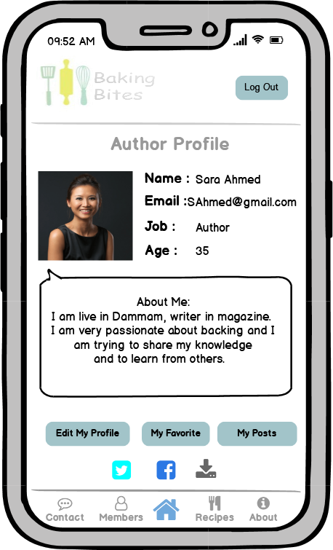

Author’s Profile

The **Members Page** appears like this if the user is a regular member.

Subscriber’s Profile

**2.9 Posting a Recipe**

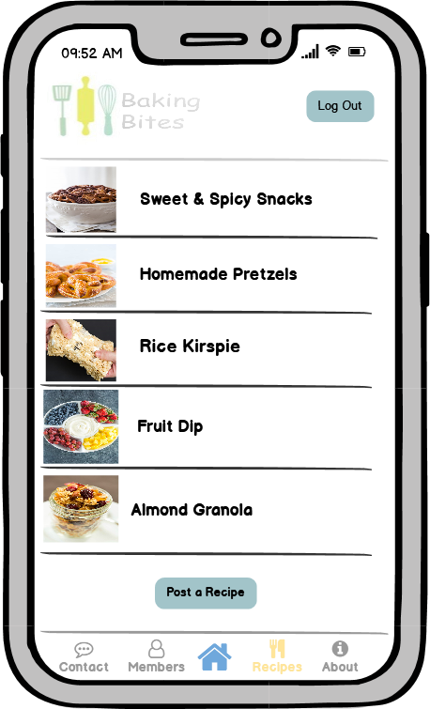 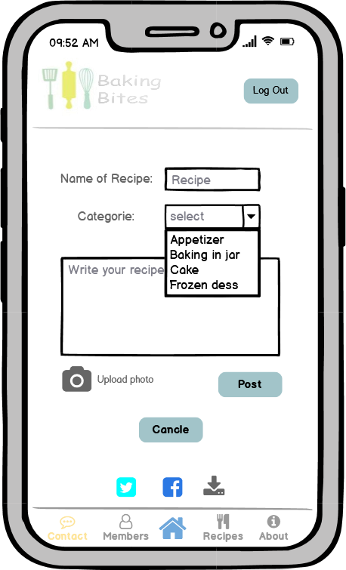

Admin and Author are the only members who can post recipes.